**Guide to Reviewing Your Results**

After the survey closes, you’ll be able to view your organization’s results in the survey platform, Culture Amp. In this guide, you’ll find steps to explore the following:

1. Logging In to Culture Amp
2. Your Dashboard
3. Exporting Your Data
4. Summary Tab
   1. Information About Factors
5. Participation Tab
6. Questions Tab
   1. Rating Questions
   2. Free Text & Multiple Choice Questions
   3. Comparisons
7. Heatmap Tab
8. Comments Tab
9. Taking Action

### 

| **Logging In to Culture Amp** Use your email address as your login. Your password can be set or reset through the link below. It looks like a password reset page and can also be used to create an account:  <https://identity.cultureamp.com/session/password/new>  Once your password is set, you can log in directly on cultureamp.com. |  |
| --- | --- |

### **Your Dashboard**

After you log in, click on “Surveys” at the top of the screen, then “Reports.”

You’ll see a list of the surveys your organization has participated in. If this is your first survey with Leading Edge, there will only be one option. Click on the “2025 Employee Experience Survey,” and you’ll be taken to your results dashboard.

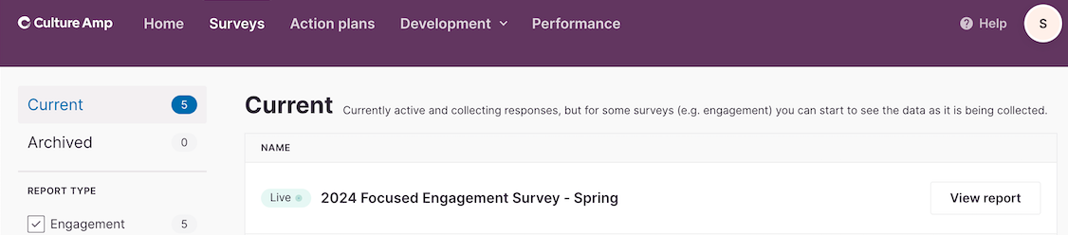

*(Example taken from the 2024 Focused Engagement Survey)*

Once you access the current survey report, you can navigate your data by exploring the different menu tabs: Summary, Insight, Participation, Questions, Heatmap, and Comments (if applicable).



| **Exporting Your Data** In the upper right corner, there is an option to export your survey data to a PDF, an Excel file, a .CSV file or a PowerPoint deck.  Generally, we recommend exporting data to an Excel file because it’s often easier to sort, filter, and format your data. **Summary Tab** The Summary tab shows your overall employee engagement score, your top strengths, and some areas for improvement. We recommend using this tab only to get a high-level overview of your data and spending more time in the Questions tab for deeper analysis. |  |
| --- | --- |

Remember that when you look at the charts for your scores, you’ll see percentages for favorable scores, neutral scores, and unfavorable scores.

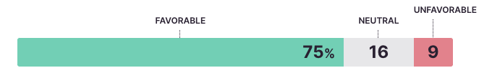

**Insight Tab**

When you click on the Insight tab, you’ll see the total number of your employees that participated and your participation rate on the left-hand side bar. 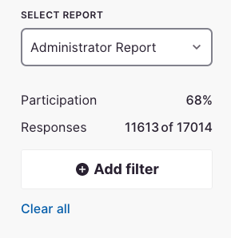

On the page, you’ll also see your Employee Engagement score and the scores for each of the other survey factors. When you click on a factor, you can explore the questions in that factor’s category. You can also see how various demographic groups (either shared by participants on the survey or submitted via your employee roster) compare to one another.

| **Information About Factors** We think of factors as categories of questions on the survey. **The key factor is Employee Engagement** because it includes questions about employee experience like pride, motivation, and intent to stay.    The other survey factors are made up of a series of questions that contribute to your organization’s overall employee engagement around pride, motivation, intent to stay, and more. You can [click here to view](https://leading-edge.cdn.prismic.io/leading-edge/Z6Y80JbqstJ9-YBA_SurveyFactorDefinitions.pdf) the full list of survey factors and their definitions in relation to the survey.  Impact Top 5: If you scroll to the bottom of the Insight screen, you’ll see the top 5 questions which have been statistically identified to have the highest impact on Employee Engagement. This means that by focusing on these questions and improving their scores, you are generally more likely to improve your Engagement Score. |
| --- |

### **Participation Tab**

This tab shows the demographic breakdown of all survey respondents. You can see how many responses you have by any of the demographics provided on your organization’s HRIS and the demographics asked on the survey. Any demographic question asked on the survey will appear here and will be identified with “SR” to indicate that it’s self-reported.

**PRO TIPS**:

1) You can use this data to build presentation visuals that show what groups of staff took the survey. You can also use this data next year to encourage participation with a more personalized approach for groups with lower participation rates.

2) When you see a larger spread of scores for a particular demographic, take note. We’ll explore this on the Heatmap tab.

### **Questions Tab**

This is your comprehensive picture of the entire survey. Every question from the survey, except the demographic questions, can be viewed on this tab.

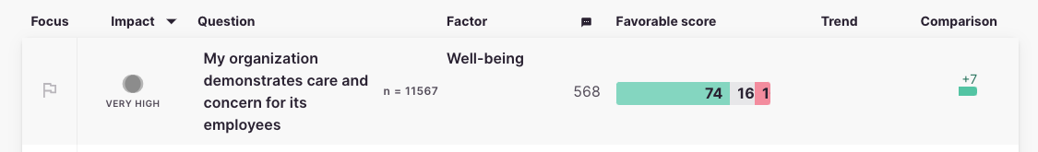

#### Rating Questions

You can organize questions by focus, impact, factor, favorability score, comparison deviation, and even alphabetical order. If any of your employees left comments on any of the questions, you can also organize them by the number of comments on each question. You can order and reverse the order on any heading by clicking on the header.

#### **Free Text & Multiple Choice Questions**

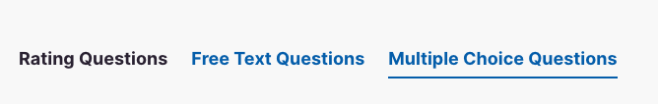

The Questions tab also gives you access to Free Text Questions and the Multiple Choice Questions. Spend some time looking over these pages to explore the written commentary from staff and the narrative emerging from the comments. These sections can often provide more nuance to your data, and employees may even share helpful suggestions.

| **Comparisons** In the upper right corner, you will see the “Compared To” drop-down menu. Here you will discover comparisons that may be available for your organization based on past survey participation:   * Your organization’s data from the 2023 and 2022 Employee Experience Surveys if your organization participated. * Your organization’s data from the Spring and Fall Focused Engagement Surveys if your organization participated. * A United States benchmark from Culture Amp benchmark from all engagement surveys taken across different industries. * The entire cohort of participating organizations in the 2025 Employee Experience Survey. * **Not Pictured:** Data from all participating organizations that are of the same Team Size as your organization (based on your registration selection). * **Not Pictured**: Data from all participating organizations that are of the same Org Type as your organization (based on your registration selection). |  |
| --- | --- |

### **Heatmap Tab**

This is your visual guide to viewing your data by demographics and looking at different slices of your organization in a comparative way.

| For example, you can select “SR - Age” as your demographic through the drop-down menu. This will first load your data as Δ Delta scores—the % point difference from the average—but you can view your data as percentage (%) Scores as well.  This selection will show us how each sub-group (in this case self-reported age) answered the questions under each factor. |  |
| --- | --- |

The colors represent their relationship to the average (the numbers you saw on the Insights screen and can now see again in the first column). The more saturated the color, the farther that score deviates from your organization’s average. Culture Amp offers two color options:

* Red/Green - Red represents lower than average, and green represents higher than average.
* Blue/Yellow - Yellow represents lower than average, and blue represents higher than average.

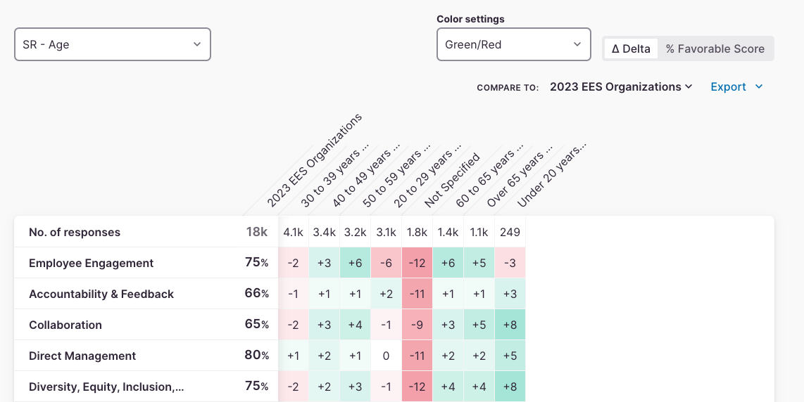

*(Example taken from the 2023 Employee Experience Survey)*

Click on a factor to expand it and see all the questions within that category, as well as favorability scores.

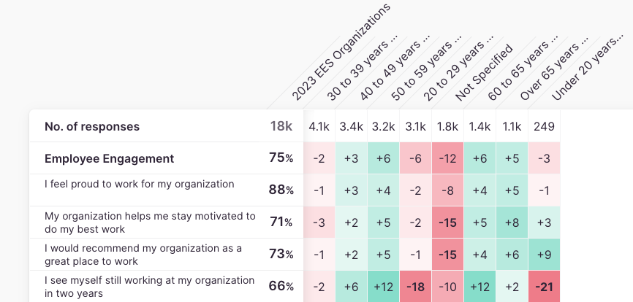

*(Example taken from the 2023 Employee Experience Survey)*

You can dig into the data even further, as long as you have large enough response groups. **Any group with less than four (4) responses will not have any available data.** If there is a group of 1, the next smallest group regardless of size will also be hidden to protect the group of 1.

| **Filters**: By using filters, you can explore your data with greater detail. On the left-side menu under your participation rates, you will find an “Add filter” button.  Click it to see a drop-down menu of all available demographics, and select the demographic you want to explore.  For example, you can look at “SR - Gender” to view the scores of a specific self-reported gender by departments. Choose the gender you’d like to analyze based on age.  **PRO TIP**: Reverse this process by selecting Gender as your Heatmap demographic and SR - Age as your filter. Then you can look at how different genders within a specific age range feel about various factors and questions. |  |
| --- | --- |

### **Comments Tab**

In the Comments tab, you will be able to see any verbatim comment that was shared by your team.

There are several open-ended questions, and every rating question gives your employees the chance to add a comment. Click on a question to expand and see the comments.

| You will also have the ability to filter comments based on:   * Topic (or theme) - Each comment has a tag showing the topic it’s grouped under. * Sentiment (positive, neutral, or negative) - Each comment has a tag based on the sentiment determined by the algorithm. **Note**: The algorithm doesn’t always detect the nuance of language correctly, so we recommend reading through all comments for accuracy. * Rating (the rating the employee gave that question) |  |
| --- | --- |

To protect the identity and responses of employees, comments cannot be filtered by demographic.

| **PRO TIP**: Export your comments and run them through a word cloud generator to see what words come up most. Before you do, remove all the conjunctions and articles, so they don’t skew your analysis. Many free word cloud tools are available online.  By navigating to the Topics and Themes tab, you can find a bubble chart mapping the frequency and rating of comments. The larger the bubble, the more comments you have pertaining to that topic. When you click on any of the bubbles, you will be taken to the comments list filtered for that topic. |  |
| --- | --- |

### **Taking Action**

| Visit the Questions tab again.  Here, the Culture Amp algorithm marks 3 questions with a green flag for your organization to focus on. It takes into consideration the impact on employee engagement, the favorability score, and the comparison to benchmarks. Keep in mind that, while the algorithm can be a helpful start, it may not capture all of the areas on which your organization would like to focus its efforts.  You can filter the questions by “Focus” to bring the recommendations from Culture Amp to the top. You can also read more about the Focus agent by clicking “What does this mean?”  To choose the Focus agents of your preference, click on the flag next to the question.  **PRO TIP**: Sort your questions by favorability score to discover your top highest favorability scores and then reverse the order to see your lowest scores. Mark the lowest scoring questions for which you think you can really move the needle and bring them up in your consultations with an organizational development expert. |  |
| --- | --- |
| Once you have selected at least one focus area, you can click the “Take Action” tab to find a dashboard of your focus areas. |  |

On the Action Plan page, you can view your focus areas, or questions from the survey that you want to explore with action steps.

Click on “Create action” to view inspirations and ideas from Culture Amp related to each focus area.

You can select inspirations you like, customize them or add deadlines, and add them to your actions list. You even create your own with custom metrics, deadlines, and more. This is a great tool to use as you figure out what action items you want to prioritize.

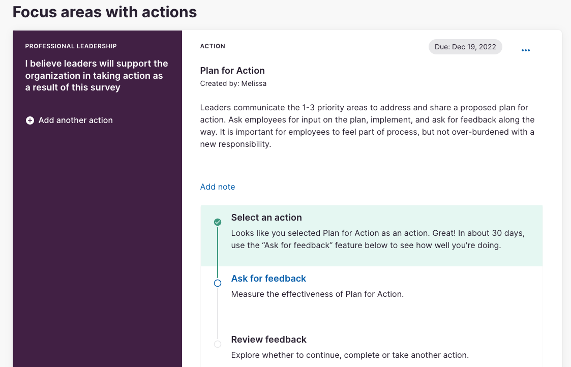

**Please email us if you have any questions at** [**surveys@leadingedge.org**](mailto:surveys@leadingedge.org)**. Happy Exploring!**