**How to Complete Your HRIS**

## **What is an HRIS?**

An HRIS, or Human Resource Information Sheet, is a spreadsheet you’ll submit to us that lists all of the employees who will be invited to participate in the survey and their corresponding information. You can [**access the template here**](https://leading-edge.cdn.prismic.io/leading-edge/Z6Y795bqstJ9-YAM_2025HRISTemplate.xlsx) (automatic Excel download).

## **Why do we need an HRIS?**

We need your HRIS to enter the names and email addresses of your staff into Culture Amp. This way, the Culture Amp system can send out unique survey links to each employee participating in the survey. It’s also where you can customize demographic information about your staff, which you can use to sort your results and analyze your data once the survey closes.

| **How do we submit our HRIS?**  You’ll submit the HRIS within the Registration Form. Your organization’s registration to participate will be complete after submitting the Registration Form and HRIS by the April 4, 2025 deadline. | **Quick Tips for Success:**   1. Copy individual work emails from your HR database 2. Check for spelling errors, inconsistencies, and typos 3. Categorize employees in groups of 4 or more 4. Avoid adding or reformatting any of the columns |
| --- | --- |

**Who do we contact for help?**

You can reach out to us at [surveys@leadingedge.org.](mailto:surveys@leadingedge.org) We’re happy to help!

## 

## **What information is required?**

## We need three pieces of information to administer the survey to your staff:

## **Column A ­– First Name**: Fill in each employee’s **first name only**. Culture Amp uses this information to customize the survey invitation and reminders. Duplicate first names are not a problem, as the system differentiates individuals by their unique email addresses.

## **Column D – Email**: Enter a unique work email address for each employee. Since individuals with incorrect or misspelled email addresses will NOT immediately have access to the survey, we recommend copying and pasting emails directly from your HR database.

## ***Note****:* Leading Edge strongly advises using work emails for staff. Employees who receive the survey in their personal email may not know the context of the survey, or may not check their email often and miss the opportunity to complete it.

## **Column G – Organization**: Fill in your organization’s full, formal, and unabbreviated name for the entire column. If your organization’s location is part of your organization’s name, include that information as well. For example, for a Federation, please write out: *Jewish Federation of [location]*.

**How do we complete the other columns on the HRIS?**

We encourage you to fill in any of the following optional columns based on the data your organization is the most interested in seeing.

* **Column B – Last Name**: This column may be helpful to complete if your organization has multiple people with the same first name, and you want to ensure that each employee’s information is correct. Culture Amp does not recommend including last names when you submit your HRIS, but you may include them if it helps you stay organized.
* **Column C – Preferred Name**: If employees use a shortened name or nickname, provide it here. Culture Amp will default to preferred names when personalizing emails. If left blank, the system will use first names listed in Column A.
* **Column E – Date of Birth:** Add employee dates of birth if you’d like to view and filter your data by age ranges. Dates entered in this column must be formatted as MM/DD/YYYY (ie: 01/01/1900). The Culture Amp system cannot read dates in any other format. Note: Staff will also have the option to share their age range on the survey.
* **Column F – Start Date:** Add employee start dates to view and filter your data by tenure. As with dates of birth, start dates must be formatted as MM/DD/YYYY. Note: Staff will also have the option to share their tenure on the survey.
* **Column H – Department**: Complete this column to see your data sorted by department. When listing department names, be sure to maintain spelling consistencies and provide data in groups of 4 or more.
* **Column I – Manager**: If your organization has managers with teams of 4 or more employees, you can complete this column to view data for employees with different managers.
  + ***Note:*** If your organization has managers with smaller teams, it may be helpful to include mid-level managers or executive team members to meet the confidentiality threshold, or to leave this field blank.
* **Column J – Employment Type**: Consider using this column to differentiate between employee classifications such as Full-time, Part-time, Union, Non-union, or Contractor. Be sure to provide data in groups of 4 or more.
  + ***Note***: If you vary spelling and capitalization, the survey system will separate staff into different categories, and you’ll be unable to compare like groups. Follow the same convention for every staff member (i.e. “Full-time” for all full-time staff, and “Part-time” for all part-time staff.)
* **Column K – Job Title:** This column can be helpful if you have a lot of staff with similar titles, like teachers or social workers. This also helps Leading Edge with our higher-level analysis of the sector overall. Avoid abbreviations as much as possible.
* **Column L – Job Level:** This column can help you see trends across job level, without the specificity of job title. We recommend using the options: Individual Contributor, Manager, Manager of Managers, and Executive Team. Note: Staff will also have the option to share their job level on the survey as well.
* **Columns M through N – Other 1 and Other 2**: You can use these ***two*** ***optional columns*** to categorize any other information that’s relevant for your organization in groups of 4 or more. For example, you can designate employees who work at different campuses or locations, or those who started before or after a certain date or event. To get the most out of these columns, we suggest reviewing the demographic questions that will be asked on the survey to avoid duplicating information.
  + ***Note***: Since the HRIS columns cannot be edited or reformatted, you’ll need to keep a record of the demographics you’re measuring in these columns.

**Example**

*Columns A - G are shown below. Note the submission of unique work email addresses and the MM/DD/YYYY format in Column E.*

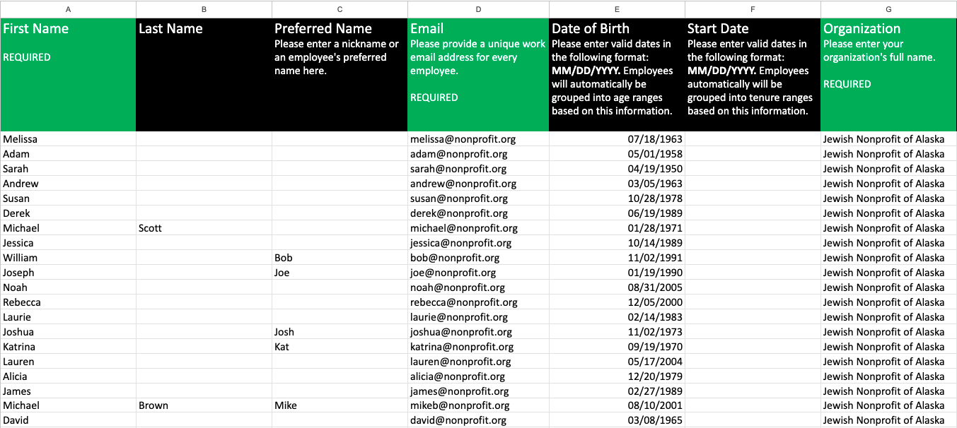

*Columns H-N are shown below. Note the demographic groupings of at least 4 employees, the consistent spelling in Column J, and unchanged title in Column M.*

